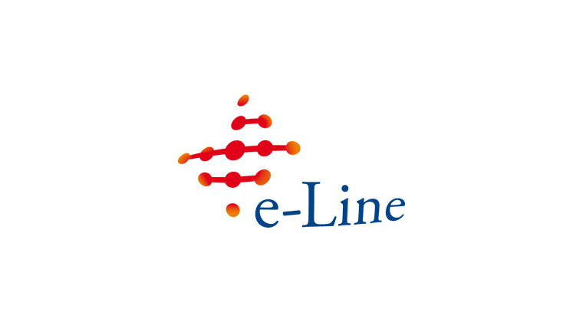

Program November 5th

13:00 - 13:20 Welcome and introduction to the e-Line initiative Coen Voormeulen

13:20 - 14:00 The e-Line system, an overview Ron Baremans

14:00 - 14:20 Coffee/tea break

14:20 - 15:00 Live demonstration of the e-Line platform Ron Baremans

15:00 - 15:30 The e-Line experience Richard Bronger,

ABN/AMRO

15:30 - 16:00 Coffee/tea break

16:00 - 16:45 Panel discussion, how to join the initiative

16:46 - 18.00 Drinks and Dutch Snacks

Social event An evening with music and excellent Italian food

Location Pasta e Basta, Nieuwe Spiegelstraat 8, Amsterdam Centre.

Start 20:30

Program November 6th
09:00 - 10:15 How to build your own reports Ben van Trierum
10:15 - 10:30 Short coffee/tea break
10:30 - 11:15 The input functionality and input formats Roger Geraedts
11:15 - 12:00 e-Line and XBRL Tom Staneke
12:00 - 13:00 Lunch
13:00 Start of the VIII CEBS XBRL Workshop

